Introduction (Your Role And Responsibilities):
  - What is the game? (title, genre, and one-sentence concept)
The title of our game is “Grave Wave”, and it is a first-person, horde-based, round shooter. You and a friend are wizards who are trying to finish all the rounds and defeat the boss in order to save the town.
  - What was your role in the team for the multiplayer game? (e.g., systems design, level design, UI/UX, narrative, programming, audio, production)aa
Level design, Enemy asset creation and animation, and assisted in finding audio for the menu and enemies.
  - What were your tasks for the multiplayer game?
My tasks for the multiplayer game were to create the main area where the game takes place, as well as to create the enemies' designs and animations.
  - Briefly describe what you delivered this round (features, coding, asset integrated, animations, shaders/lighting, UI, audio, documentation, testing, etc.)
I delivered the level for our game, with a three-lane layout that allows separate avenues of movement for the players. I delivered the animation and assets for the enemies and created a toon shader for some of the particles we will attach to them. I also added the small amount of lighting present in the level. I also made a toon shader that was attached to the smoke particle effect.
Design Process (How You Worked):
  - How you moved from your initial idea, to plan, to networked multiplayer implementation.
Because the level doesn’t change between players, I didn’t need to focus on changing things for each player, so I tried to focus on a map design method that has been tried and used many times before, so it wasn’t anything ground breaking or different. And I believed that keeping the level simple would aid our simpler mechanics and not overcomplicate the player's experience.
  - What you prioritised and why (game feel, readability, cohesion, polish, scope cuts)
  - How you collaborated (feedback loops, workflow, versioning/handovers, integrating other teammates’ work)
We collaborated by focusing on our design areas and assisting each other where needed. For example, when Nayuvka started working on the enemy script, she was also going to do the enemy designs and animation, so I took on the role of designing and animating the enemies to lighten her load. The main collaboration came from communicating with each other and trying to split tasks as evenly as possible, which allowed us to focus and create a meaningful experience individually and combine them in the end.
  - What changed over time and why (design decisions, technical constraints, visual/audio constraints, scope cuts)
When I started designing the level, I drew inspiration from Call of Duty multiplayer maps, most of which use a three-lane layout that lets players explore different parts of the level simultaneously. Initially, the level was very clustered and felt overcrowded, especially with the asset pack we decided to use. So, when I started to create the level, I went through a few passes before landing on the current. Mainly from changing the way the terrain was laid out, then changing the buildings' positions to allow for better play and space.
  - How you ensured your work matched the team’s overall style and plan?
When creating the level, I would often send images and progress reports to the group to get their feedback and make changes based on that. Even when it came to selecting the asset packs we used and tried, I would consult with them first on asset creation and texturing, just so things would match.
  - Include 1 to 3 visuals if useful (screenshots, diagrams, flowcharts, UI wireframes, level maps, animation state diagrams, lighting/shader screenshots, etc.).
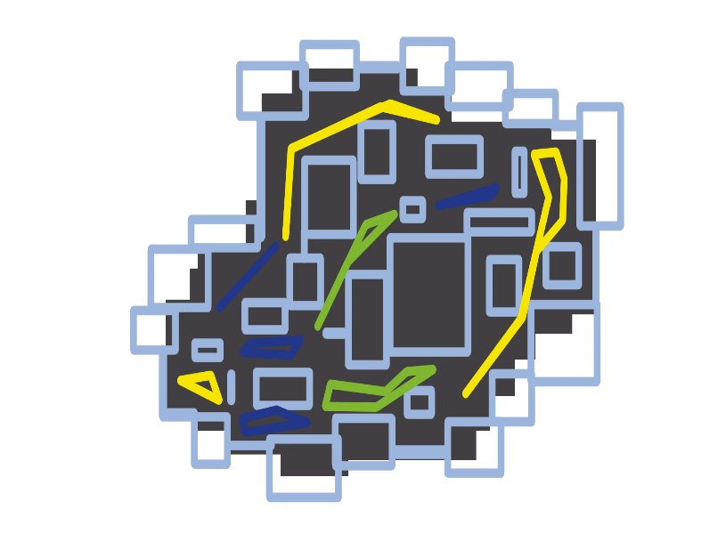 Figure 1: Initial level design layout
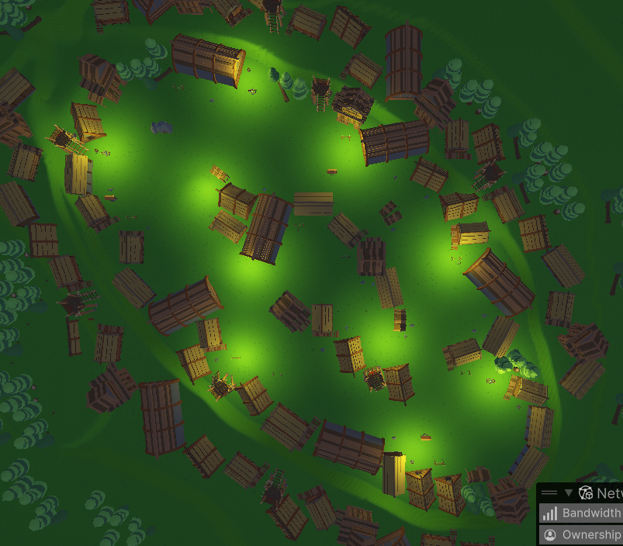 Figure 2: Current level layout, larger spawn and boss area, so it isn't as crowded in early and late game
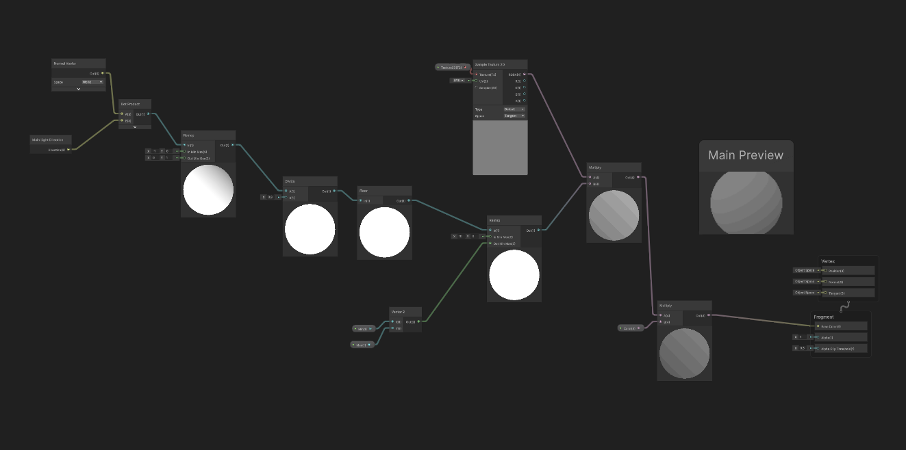 Figure 3: Shader graph for the smoke toon shader
Literature Review (Research That Informed Your Design):
  - Summarise 3 to 6 relevant sources (or more if you want, but keep it tight).
  - Explain how each source influenced your thinking/design (not just what it says)
  - Connect research to your actual design decisions in this iteration, for example, improving game feel and feedback.
Critical Reflection (Challenges, Changes And Next Steps):
  - What you found challenging during the making of this vertical slice (technical, design, scope, asset integration, animation setup, shaders/lighting, audio integration, playtesting, etc.)

  - What didn’t work as expected, and why (bugs, pipeline issues, mismatched style, performance, readability)
Some things that didn’t work as expected were, one, the use of terrain within the level. Once we implemented the final level, I had given the plane some slight variations in height, so the level didn’t seem flat and would appear more interesting, but when the enemies would spawn onto the level with the terrain variations, they would slide about the level. So, we flattened the playable area, allowing the enemies to move more smoothly and not look silly while trying to attack you as the player. A second thing that we had to remove was some of the terrain paint, as it caused frame crashes, because the game wasn’t optimised to not render what was not in view, which made our frames drop with all the extras added onto the terrain.
  - What you would change if you had more time (or if you could rewind your decisions)
If I could rewind, I would remake the level on a smaller scale, as I scaled all the assets to look suitable on the terrain. In doing so, I couldn’t fully utilise the terrain editor to place trees and other miscellaneous items as they would appear too small in comparison to the scaled-up assets. As well as properly importing the asset pack the first time and using the FBXs provided in the asset pack. This caused a lot of wasted time for me, manually placing trees and manually applying materials to assets. In summary, what I would’ve done if I could rewind time is that I would utilise the ease of life systems already in the software rather than brute forcing my way through the software to get the same results in more time, which in turn would’ve allowed me more time to help my group.

